**EDC_V UNIT**

**Feedback Concept In Amplifiers:**

Feedback is the process by which a fraction of the output signal, either a voltage or a current, is used as an input. If this feedback fraction is opposite in value or phase (“anti-phase”) to the input signal, then the feedback is said to be **Negative Feedback**, or degenerative feedback.

Negative feedback opposes or subtracts from the input signals giving it many advantages in the design and stabilisation of control systems. For example, if the systems output changes for any reason, then negative feedback affects the input in such a way as to counteract the change.

Feedback reduces the overall gain of a system with the degree of reduction being related to the systems open-loop gain. Negative feedback also has effects of reducing distortion, noise, sensitivity to external changes as well as improving system bandwidth and input and output impedances.

Feedback in an electronic system, whether negative feedback or positive feedback is unilateral in direction. Meaning that its signals flow one way only from the output to the input of the system. This then makes the loop gain, G of the system independent of the load and source impedances.

As feedback implies a closed-loop system it must therefore have a summing point. In a negative feedback system this summing point or junction at its input subtracts the feedback signal from the input signal to form an error signal, β which drives the system. If the system has a positive gain, the feedback signal must be subtracted from the input signal in order for the feedback to be negative as shown.

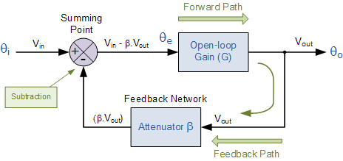

The circuit represents a system with positive gain, G and feedback, β. The summing junction at its input subtracts the feedback signal from the input signal to form the error signal Vin - βG, which drives the system.

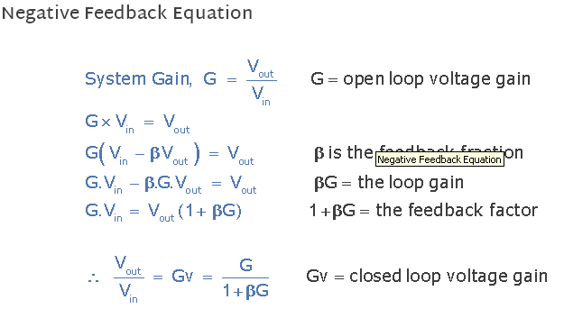

**Effects of Negative Feedback**

If the open-loop gain, G is very large, then βG will be much greater than 1, so that the overall gain of the system is roughly equal to 1/β. If the open-loop gain decreases due to frequency or the effects of system ageing, providing that βG is still relatively large, the overall system gain does not change very much. So negative feedback tends to reduce the effects of gain change giving what is generally called “gain stability”.

Some of the Advantages of negative feedback:

a)      Input resistance increases

b)      Output resistance decreases

c)      Bandwidth increases

d)     Non linear distortion decreases

e)      Frequency distortion decreases

f)       Sensitivity will be decreased

g)      Gain stability

The main disadvantage of negative feedback is decrease in overall gain. The gain and feedback factor in an amplifier are often functions of frequency, so the feedback may lead to positive feedback.

## The effect of negative feedback on voltage gain, BW, Noise, nonlinear distortion, Ri, Ro of a voltage amplifier

The voltage gain, bandwidth, noise, nonlinear distortion, input resistance, output resistance are

Voltage gain with feedback = Voltage gain without feedback* desensitivity factor (since desensitivity factor << 1 in negative feedback, hence Voltage gain without feedback < gain without feedback).

Band width with feedback = Band width without feedback/ desensitivity factor (since desensitivity factor << 1 in negative feedback, hence Band width without feedback > Band width without feedback).

Noise with feedback = Noise without feedback* desensitivity factor (since desensitivity factor << 1 in negative feedback, hence Noise without feedback > Noise without feedback).

Non linear distortion with feedback = Non linear distortion without feedback* desensitivity factor (since desensitivity factor << 1 in negative feedback, hence Non linear distortion without feedback > Non linear distortion without feedback).

Non linear distortion with feedback = Non linear distortion without feedback* desensitivity factor (since desensitivity factor << 1 in negative feedback, hence Non linear distortion without feedback > Non linear distortion without feedback).

Input resistance with feedback = Input resistance without feedback/ desensitivity factor (since desensitivity factor << 1 in negative feedback, hence Input resistance without feedback > Input resistance without feedback).

Output resistance with feedback = Output resistance without feedback* desensitivity factor (since desensitivity factor << 1 in negative feedback, hence Output resistance without feedback > Output resistance without feedback),

## The different types of feedback topologies:

There are four different types of feedback topologies based on type of output signal and feedback signal (voltage or current signal). Voltage feedback is taken in series with the load and current feedback is taken in shunt with the load. They are

a)**Voltage-series:** Output signal is voltage signal, feedback signal is voltage signal. Also called as series-series feedback. It is employed in voltage amplifiers.

b)**Current series:** Output signal is current signal, feedback signal is voltage signal. Also called as shunt-series feedback. It is employed in Transconductance amplifiers.

c)**Current shunt:** Output signal is current signal, feedback signal is current signal. Also called as shunt-shunt feedback. It is employed in current amplifiers.

d)**Voltage shunt:** Output signal is voltage signal, feedback signal is current signal. Also called as shunt-shunt feedback. It is employed in current amplifiers.

The first word indicates the type of output signal and the second word indicates the manner in which feedback signal is taken whether it is taken in series or shunt with the load.

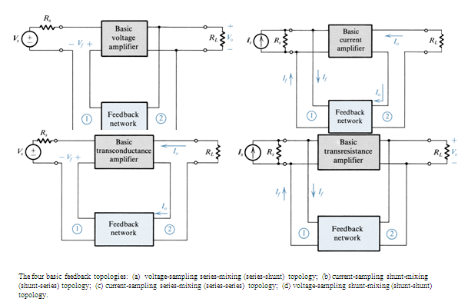

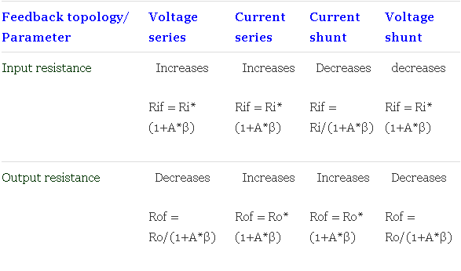

An **oscillator** generates output without any ac input signal. An electronic oscillator is a circuit which converts dc energy into ac at a very high frequency. An amplifier with a positive feedback can be understood as an oscillator.

### Amplifier vs. Oscillator

An **amplifier** increases the signal strength of the input signal applied, whereas an **oscillator** generates a signal without that input signal, but it requires dc for its operation. This is the main difference between an amplifier and an oscillator.

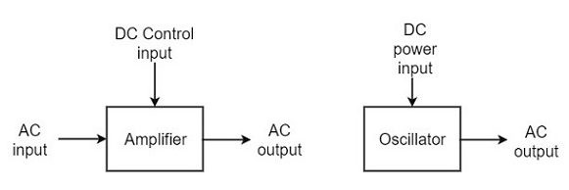

## Classification of Oscillators

Electronic oscillators are classified mainly into the following two categories −

* **Sinusoidal Oscillators** − The oscillators that produce an output having a sine waveform are called **sinusoidal** or **harmonic oscillators**. Such oscillators can provide output at frequencies ranging from 20 Hz to 1 GHz.
* **Non-sinusoidal Oscillators** − The oscillators that produce an output having a square, rectangular or saw-tooth waveform are called **non-sinusoidal** or **relaxation oscillators**. Such oscillators can provide output at frequencies ranging from 0 Hz to 20 MHz.

We will discuss only about Sinusoidal Oscillators in this tutorial. You can learn the functions of non-sinusoidal oscillators from our [Pulse Circuits](https://www.tutorialspoint.com/pulse_circuits/index.htm) tutorial.

## Sinusoidal Oscillators

Sinusoidal oscillators can be classified in the following categories −

* **Tuned Circuit Oscillators** − These oscillators use a tuned-circuit consisting of inductors (L) and capacitors (C) and are used to generate high-frequency signals. Thus they are also known as radio frequency R.F. oscillators. Such oscillators are Hartley, Colpitts, Clapp-oscillators etc.
* **RC Oscillators** − There oscillators use resistors and capacitors and are used to generate low or audio-frequency signals. Thus they are also known as audio-frequency (A.F.) oscillators. Such oscillators are Phase –shift and Wein-bridge oscillators.
* **Crystal Oscillators** − These oscillators use quartz crystals and are used to generate highly stabilized output signal with frequencies up to 10 MHz. The Piezo oscillator is an example of a crystal oscillator.
* **Negative-resistance Oscillator** − These oscillators use negative-resistance characteristic of the devices such as tunnel devices. A tuned diode oscillator is an example of a negative-resistance oscillator.

## Nature of Sinusoidal Oscillations

The nature of oscillations in a sinusoidal wave are generally of two types. They are **damped** and **undamped oscillations**.

### Damped Oscillations

The electrical oscillations whose amplitude goes on decreasing with time are called as **Damped Oscillations**. The frequency of the damped oscillations may remain constant depending upon the circuit parameters.

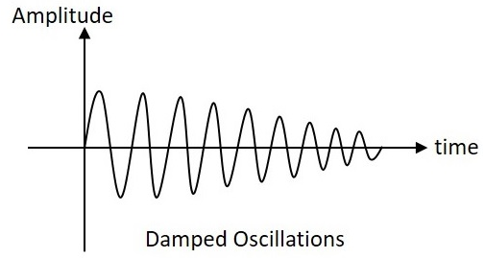

Damped oscillations are generally produced by the oscillatory circuits that produce power losses and doesn’t compensate if required.

### Undamped Oscillations

The electrical oscillations whose amplitude remains constant with time are called as **Undamped Oscillations**. The frequency of the Undamped oscillations remains constant.

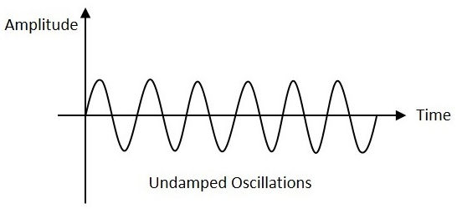

Undamped oscillations are generally produced by the oscillatory circuits that produce no power losses and follow compensation techniques if any power losses occur.

An amplifier with positive feedback produces its output to be in phase with the input and increases the strength of the signal. Positive feedback is also called as**degenerative feedback** or **direct feedback**. This kind of feedback makes a feedback amplifier, an oscillator.

The use of positive feedback results in a feedback amplifier having closed-loop gain greater than the open-loop gain. It results in **instability** and operates as an oscillatory circuit. An oscillatory circuit provides a constantly varying amplified output signal of any desired frequency.

## The Oscillatory Circuit

An oscillatory circuit produces electrical oscillations of a desired frequency. They are also known as **tank circuits**.

A simple tank circuit comprises of an inductor L and a capacitor C both of which together determine the oscillatory frequency of the circuit.

To understand the concept of oscillatory circuit, let us consider the following circuit. The capacitor in this circuit is already charged using a dc source. In this situation, the upper plate of the capacitor has excess of electrons whereas the lower plate has deficit of electrons. The capacitor holds some electrostatic energy and there is a voltage across the capacitor.

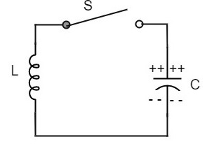

when the switch **S** is closed, the capacitor discharges and the current flows through the inductor. Due to the inductive effect, the current builds up slowly towards a maximum value. Once the capacitor discharges completely, the magnetic field around the coil is maximum.

This continuation of charging and discharging results in alternating motion of electrons or an **oscillatory current**. The interchange of energy between L and C produce continuous **oscillations**.

In an ideal circuit, where there are no losses, the oscillations would continue indefinitely. In a practical tank circuit, there occur losses such as **resistive** and**radiation losses** in the coil and **dielectric losses** in the capacitor. These losses result in damped oscillations.

## Frequency of Oscillations

The frequency of the oscillations produced by the tank circuit are determined by the components of the tank circuit, **the L** and **the C**. The actual frequency of oscillations is the **resonant frequency** (or natural frequency) of the tank circuit which is given by



The parts of the practical oscillator circuit.

* **Tank Circuit** − The tank circuit consists of an inductance L connected in parallel with capacitor **C**. The values of these two components determine the frequency of the oscillator circuit and hence this is called as **Frequency determining circuit**.
* **Transistor Amplifier** − The output of the tank circuit is connected to the amplifier circuit so that the oscillations produced by the tank circuit are amplified here. Hence the output of these oscillations are increased by the amplifier.
* **Feedback Circuit** − The function of feedback circuit is to transfer a part of the output energy to LC circuit in proper phase. This feedback is positive in oscillators while negative in amplifiers.

## Frequency Stability of an Oscillator

The frequency stability of an oscillator is a measure of its ability to maintain a constant frequency, over a long time interval. When operated over a longer period of time, the oscillator frequency may have a drift from the previously set value either by increasing or by decreasing.

The change in oscillator frequency may arise due to the following factors −

* Operating point of the active device such as BJT or FET used should lie in the linear region of the amplifier. Its deviation will affect the oscillator frequency.
* The temperature dependency of the performance of circuit components affect the oscillator frequency.
* The changes in d.c. supply voltage applied to the active device, shift the oscillator frequency. This can be avoided if a regulated power supply is used.
* A change in output load may cause a change in the Q-factor of the tank circuit, thereby causing a change in oscillator output frequency.
* The presence of inter element capacitances and stray capacitances affect the oscillator output frequency and thus frequency stability.

### Principle of Feedback Amplifier & Barkhausan Criteria:

A feedback amplifier generally consists of two parts. They are the **amplifier** and the **feedback circuit**. The feedback circuit usually consists of resistors. The concept of feedback amplifier can be understood from the following figure below.

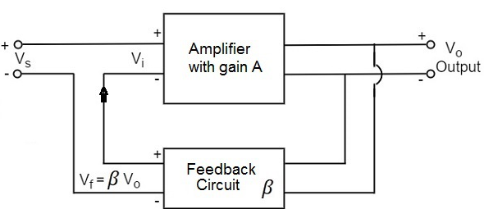

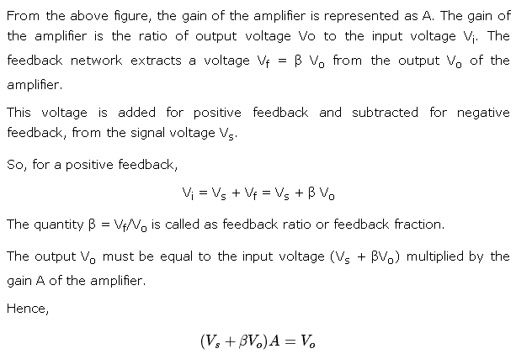

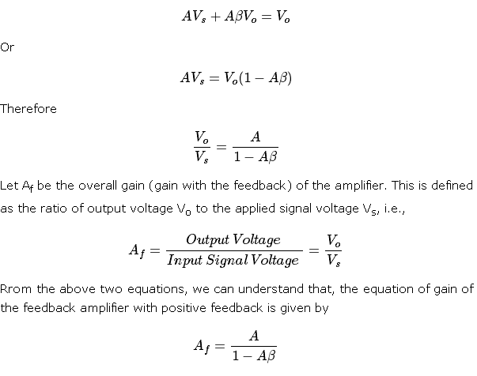

Where **Aβ** is the **feedback factor** or the **loop gain**.

If Aβ = 1, Af = ∞. Thus the gain becomes infinity, i.e., there is output without any input. In another words, the amplifier works as an Oscillator.

The condition Aβ = 1 is called as **Barkhausen Criterion of oscillations**.

Tuned circuit oscillators are the circuits that produce oscillations with the help of tuning circuits. The tuning circuits consists of an inductance L and a capacitor C. These are also known as **LC oscillators, resonant circuit oscillators** or **tank circuit oscillators**.

The tuned circuit oscillators are used to produce an output with frequencies ranging from 1 MHz to 500 MHz Hence these are also known as **R.F. Oscillators**. A BJT or a FET is used as an amplifier with tuned circuit oscillators. With an amplifier and an LC tank circuit, we can feedback a signal with right amplitude and phase to maintain oscillations.

## Types of Tuned Circuit Oscillators

Most of the oscillators used in radio transmitters and receivers are of LC oscillators type. Depending upon the way the feedback is used in the circuit, the LC oscillators are divided as the following types.

* **Tuned-collector or Armstrong Oscillator** − It uses inductive feedback from the collector of a transistor to the base. The LC circuit is in the collector circuit of the transistor.
* **Tuned base Oscillator** − It uses inductive feedback. But the LC circuit is in the base circuit.
* **Hartley Oscillator** − It uses inductive feedback.
* **Colpitts Oscillator** − It uses capacitive feedback.
* **Clapp Oscillator** − It uses capacitive feedback.

## Tuned Collector Oscillator

Tuned collector oscillators are called so, because the tuned circuit is placed in the collector of the transistor amplifier. The combination of **L** and **C** form the tuned circuit or frequency determining circuit.

**Construction**

The resistors R1, R2 and RE are used to provide d.c. bias to the transistor. The capacitors CE and C are the by-pass capacitors. The secondary of the transformer provides a.c. feedback voltage that appears across the base-emitter junction of R1 and R2 is at a.c. ground due to by-pass capacitor C. In case, the capacitor was absent, a part of the voltage induced in the secondary of the transformer would drop across R2 instead of completely going to the input of transistor.

As the CE configured transistor provides 180o phase shift, another 180o phase shift is provided by the transformer, which makes 360o phase shift between the input and output voltages. The following circuit diagram shows the arrangement of a tuned collector circuit.

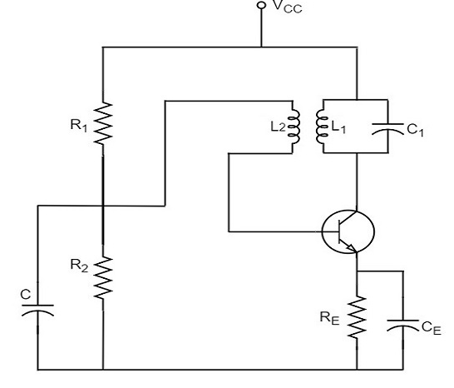

### Operation

Once the supply is given, the collector current starts increasing and charging of capacitor C takes place. When the capacitor is fully charged, it discharges through the inductance L1. Now oscillations are produced. These oscillations induce some voltage in the secondary winding L2. The frequency of voltage induced in the secondary winding is same as that of the tank circuit and its magnitude depends upon the number of turns in secondary winding and coupling between both the windings.

The voltage across L2 is applied between base and emitter and appears in the amplified form in the collector circuit, thus overcoming the losses in the tank circuit. The number of turns of L2 and coupling between L1 and L2 are so adjusted that oscillations across L2 are amplified to a level just sufficient to supply losses to the tank circuit.

Tuned collector oscillators are widely used as the **local oscillator** in radio receivers.

**HartelyOscillator:**

A very popular **local oscillator** circuit that is mostly used in **radio receivers** is the **Hartley Oscillator** circuit. The constructional details and operation of a Hartley oscillator are as discussed below.

## Construction

In the circuit diagram of a Hartley oscillator shown below, the resistors R1, R2and Re provide necessary bias condition for the circuit. The capacitor Ceprovides a.c. ground thereby providing any signal degeneration. This also provides temperature stabilization.

The capacitors Cc and Cb are employed to block d.c. and to provide an a.c. path. The radio frequency choke (R.F.C) offers very high impedance to high frequency currents which means it shorts for d.c. and opens for a.c. Hence it provides d.c. load for collector and keeps a.c. currents out of d.c. supply source

### Tank Circuit

The frequency determining network is a parallel resonant circuit which consists of the inductors L1 and L2 along with a variable capacitor C. The junction of L1and L2 are earthed. The coil L1 has its one end connected to base via Cc and the other to emitter via Ce. So, L2 is in the output circuit. Both the coils L1 and L2are inductively coupled and together form an **Auto-transformer**.The following circuit diagram shows the arrangement of a Hartley oscillator. The tank circuit is **shunt fed** in this circuit. It can also be a **series-fed**.

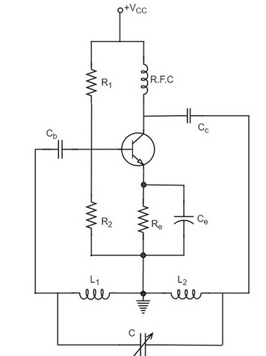

## Operation

When the collector supply is given, a transient current is produced in the oscillatory or tank circuit. The oscillatory current in the tank circuit produces a.c. voltage across L1.

The **auto-transformer** made by the inductive coupling of L1 and L2 helps in determining the frequency and establishes the feedback. As the CE configured transistor provides 180o phase shift, another 180o phase shift is provided by the transformer, which makes 360o phase shift between the input and output voltages.

This makes the feedback positive which is essential for the condition of oscillations. When the **loop gain |βA| of the amplifier is greater than one**, oscillations are sustained in the circuit.

### Frequency

The equation for **frequency of Hartley oscillator** is given as

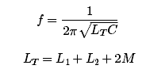

Here, **LT** is the total cumulatively coupled inductance; **L1** and **L2** represent inductances of 1st and 2nd coils; and **M** represents mutual inductance. Mutual inductance is calculated when two windings are considered.

### Advantages

* Instead of using a large transformer, a single coil can be used as an auto-transformer.
* Frequency can be varied by employing either a variable capacitor or a variable inductor.
* Less number of components are sufficient.
* The amplitude of the output remains constant over a fixed frequency range.

### Disadvantages

* It cannot be a low frequency oscillator.
* Harmonic distortions are present.

### Applications

* It is used to produce a sine-wave of desired frequency.
* Mostly used as a local oscillator in radio receivers.
* It is also used as R.F. Oscillator.

**Colpitts oscillator:**

A Colpitts oscillator looks just like the Hartley oscillator but the inductors and capacitors are replaced with each other in the tank circuit. The constructional details and operation of a colpitts oscillator are as discussed below.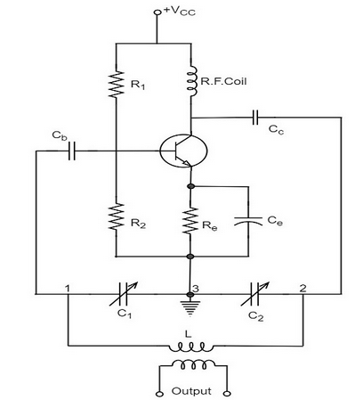

The resistors R1, R2 and Re provide necessary bias condition for the circuit. The capacitor Ce provides a.c. ground thereby providing any signal degeneration. This also provides temperature stabilization.

The capacitors Cc and Cb are employed to block d.c. and to provide an a.c. path. The radio frequency choke (R.F.C) offers very high impedance to high frequency currents which means it shorts for d.c. and opens for a.c. Hence it provides d.c. load for collector and keeps a.c. currents out of d.c. supply source.

### Tank Circuit

The frequency determining network is a parallel resonant circuit which consists of variable capacitors C1 and C2 along with an inductor L. The junction of C1 and C2 are earthed. The capacitor C1 has its one end connected to base via Cc and the other to emitter via Ce. the voltage developed across C1 provides the regenerative feedback required for the sustained oscillations.

## Operation

When the collector supply is given, a transient current is produced in the oscillatory or tank circuit. The oscillatory current in the tank circuit produces a.c. voltage across C1 which are applied to the base emitter junction and appear in the amplified form in the collector circuit and supply losses to the tank circuit.

If terminal 1 is at positive potential with respect to terminal 3 at any instant, then terminal 2 will be at negative potential with respect to 3 at that instant because terminal 3 is grounded. Therefore, points 1 and 2 are out of phase by 180o.

As the CE configuration provides 180o phase shift, it makes 360o phase shift between the input and output voltages. Hence, feedback is properly phased to produce continuous Undamped oscillations. When the **loop gain |βA| of the amplifier is greater than one, oscillations are sustained** in the circuit.

The equation for **frequency of Colpitts oscillator** is given as

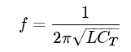 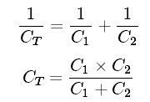

### Advantages

* Colpitts oscillator can generate sinusoidal signals of very high frequencies.
* It can withstand high and low temperatures.
* The frequency stability is high.
* Frequency can be varied by using both the variable capacitors.
* Less number of components are sufficient.
* The amplitude of the output remains constant over a fixed frequency range.

The Colpitts oscillator is designed to eliminate the disadvantages of Hartley oscillator and is known to have no specific disadvantages. Hence there are many applications of a colpitts oscillator.

### Applications

The applications of Colpitts oscillator are as follows −

* Colpitts oscillator can be used as High frequency sine-wave generator.
* This can be used as a temperature sensor with some associated circuitry.
* Mostly used as a local oscillator in radio receivers.
* It is also used as R.F. Oscillator.
* It is also used in Mobile applications.
* It has got many other commercial applications.

Phase Shift Oscillators:

One of the important features of an oscillator is that the feedback energy applied should be in correct phase to the tank circuit. The oscillator circuits discussed so far has employed inductor (L) and capacitor (C) combination, in the tank circuit or frequency determining circuit.

We have observed that the LC combination in oscillators provide 180o phase shift and transistor in CE configuration provide 180° phase shift to make a total of 360o phase shift so that it would make **a** zero difference in phase.

### Drawbacks of LC circuits

* Frequency instability
* Waveform is poor
* Cannot be used for low frequencies
* Inductors are bulky and expensive

There is an another type of oscillator circuits, which are made by replacing the inductors with resistors. By doing so, the frequency stability is improved and a good quality waveform is obtained. These oscillators can also produce lower frequencies. As well, the circuit becomes neither bulky nor expensive.

All the drawbacks of **LC** oscillator circuits are thus eliminated in **RC** oscillator circuits. Hence the need for RC oscillator circuits arise. These are also called as **Phase–shift Oscillators**.

## Principle of Phase-shift oscillators

The output voltage of an RC circuit for a sinewave input leads the input voltage. The phase angle by which it leads is determined by the value of RC components used in the circuit. The following circuit diagram shows a single section of an RC network.

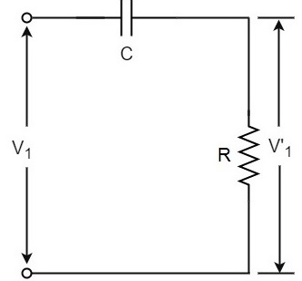

the output voltage V1’ across the resistor R leads the input voltage applied input V1 by some phase angle ɸo. If R were reduced to zero, V1’ will lead the V1 by 90o i.e., ɸo = 90o.

However, adjusting R to zero would be impracticable, because it would lead to no voltage across R. Therefore, in practice, R is varied to such a value that makes V1’ to lead V1 by 60o. The following circuit diagram shows the three sections of the RC network.

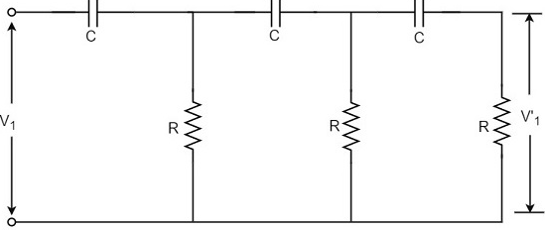

Each section produces a phase shift of 60o. Consequently, a total phase shift of 180o is produced, i.e., voltage V2 leads the voltage V1 by 180o.

## Phase-shift Oscillator Circuit

The oscillator circuit that produces a sine wave using a phase-shift network is called as a Phase-shift oscillator circuit. The constructional details and operation of a phase-shift oscillator circuit are as given below.

### Construction

The phase-shift oscillator circuit consists of a single transistor amplifier section and a RC phase-shift network. The phase shift network in this circuit, consists of three RC sections. At the resonant frequency fo, the phase shift in each RC section is 60o so that the total phase shift produced by RC network is 180o.

The following circuit diagram shows the arrangement of an RC phase-shift oscillator.

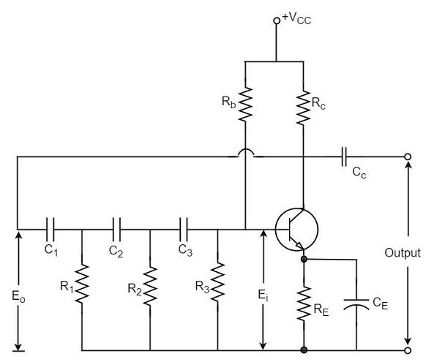

The frequency of oscillations is given by

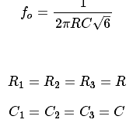

### Operation

The circuit when switched ON oscillates at the resonant frequency fo. The output Eo of the amplifier is fed back to RC feedback network. This network produces a phase shift of 180o and a voltage Ei appears at its output. This voltage is applied to the transistor amplifier.

The feedback applied will be

m=Ei/Eom=Ei/Eo

The feedback is in correct phase, whereas the transistor amplifier, which is in CE configuration, produces a 180o phase shift. The phase shift produced by network and the transistor add to form a phase shift around the entire loop which is 360o.

### Advantages

The advantages of RC phase shift oscillator are as follows −

* It does not require transformers or inductors.
* It can be used to produce very low frequencies.
* The circuit provides good frequency stability.

### Disadvantages

The disadvantages of RC phase shift oscillator are as follows −

* Starting the oscillations is difficult as the feedback is small.
* The output produced is small.

**Wein-BridgeOscillator:**

Another type of popular audio frequency oscillator is the Wien bridge oscillator circuit. This is mostly used because of its important features. This circuit is free from the **circuit fluctuations** and the **ambient temperature**.

The main advantage of this oscillator is that the frequency can be varied in the range of 10Hz to about 1MHz whereas in RC oscillators, the frequency is not varied.

## Construction

The circuit construction of Wien bridge oscillator can be explained as below. It is a two-stage amplifier with RC bridge circuit. The bridge circuit has the arms R1C1, R3, R2C2 and the tungsten lamp Lp. Resistance R3 and the lamp Lp are used to stabilize the amplitude of the output.

The following circuit diagram shows the arrangement of a Wien bridge oscillator.

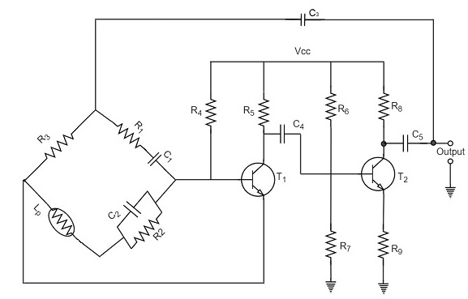

The transistor T1 serves as an oscillator and an amplifier while the other transistor T2 serves as an inverter. The inverter operation provides a phase shift of 180o. This circuit provides positive feedback through R1C1, C2R2 to the transistor T1 and negative feedback through the voltage divider to the input of transistor T2.

The frequency of oscillations is determined by the series element R1C1 and parallel element R2C2 of the bridge.

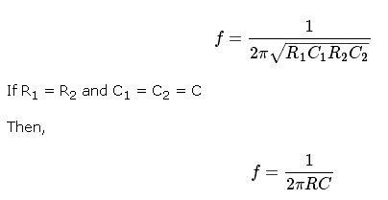

The oscillator consists of two stages of RC coupled amplifier and a feedback network. The voltage across the parallel combination of R and C is fed to the input of amplifier 1. The net phase shift through the two amplifiers is zero.

The usual idea of connecting the output of amplifier 2 to amplifier 1 to provide signal regeneration for oscillator is not applicable here as the amplifier 1 will amplify signals over a wide range of frequencies and hence direct coupling would result in poor frequency stability. By adding Wien bridge feedback network, the oscillator becomes sensitive to a particular frequency and hence frequency stability is achieved.

**Operation**

When the circuit is switched ON, the bridge circuit produces oscillations of the frequency stated above. The two transistors produce a total phase shift of 360oso that proper positive feedback is ensured. The negative feedback in the circuit ensures constant output. This is achieved by temperature sensitive tungsten lamp Lp. Its resistance increases with current.

If the amplitude of the output increases, more current is produced and more negative feedback is achieved. Due to this, the output would return to the original value. Whereas, if the output tends to decrease, reverse action would take place.

**Advantages:**

The circuit provides good frequency stability.

* It provides constant output.
* The operation of circuit is quite easy.
* The overall gain is high because of two transistors.
* The frequency of oscillations can be changed easily.
* The amplitude stability of the output voltage can be maintained more accurately, by replacing R2 with a thermistor.

**Disadvantages**

* The circuit cannot generate very high frequencies.
* Two transistors and number of components are required for the circuit construction.

**Crystal Oscillators:**

Whenever an oscillator is under continuous operation, its **frequency stability**gets affected. There occur changes in its frequency. The main factors that affect the frequency of an oscillator are

* Power supply variations
* Changes in temperature
* Changes in load or output resistance

In RC and LC oscillators the values of resistance, capacitance and inductance vary with temperature and hence the frequency gets affected. In order to avoid this problem, the piezo electric crystals are being used in oscillators.

The use of piezo electric crystals in parallel resonant circuits provide high frequency stability in oscillators. Such oscillators are called as **Crystal Oscillators**.

The principle of crystal oscillators depends upon the **Piezo electric effect**. The natural shape of a crystal is hexagonal. When a crystal wafer is cur perpendicular to X-axis, it is called as X-cut and when it is cut along Y-axis, it is called as Y-cut.

The crystal used in crystal oscillator exhibits a property called as Piezo electric property. So, let us have an idea on piezo electric effect.

### Piezo Electric Effect

The crystal exhibits the property that when a mechanical stress is applied across one of the faces of the crystal, a potential difference is developed across the opposite faces of the crystal. Conversely, when a potential difference is applied across one of the faces, a mechanical stress is produced along the other faces. This is known as **Piezo electric effect**.

Certain crystalline materials like Rochelle salt, quartz and tourmaline exhibit piezo electric effect and such materials are called as **Piezo electric crystals**. Quartz is the most commonly used piezo electric crystal because it is inexpensive and readily available in nature.

When a piezo electric crystal is subjected to a proper alternating potential, it vibrates mechanically. The amplitude of mechanical vibrations becomes maximum when the frequency of alternating voltage is equal to the natural frequency of the crystal.

## Working of a Quartz Crystal

In order to make a crystal work in an electronic circuit, the crystal is placed between two metal plates in the form of a capacitor. **Quartz** is the mostly used type of crystal because of its availability and strong nature while being inexpensive. The ac voltage is applied in parallel to the crystal.

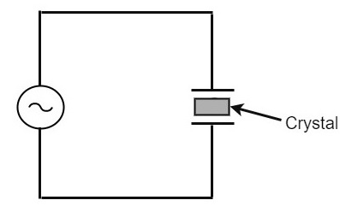

If an AC voltage is applied, the crystal starts vibrating at the frequency of the applied voltage. However, if the frequency of the applied voltage is made equal to the natural frequency of the crystal, **resonance** takes place and crystal vibrations reach a maximum value. This natural frequency is almost constant.

### Equivalent circuit of a Crystal

To represent the crystal with an equivalent electric circuit, we have to consider two cases, i.e., when it vibrates and when it doesn’t. The figures below represent the symbol and electrical equivalent circuit of a crystal respectively.

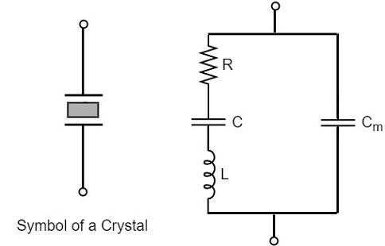

The above equivalent circuit consists of a series R-L-C circuit in parallel with a capacitance Cm. When the crystal mounted across the AC source is not vibrating, it is equivalent to the capacitance Cm. When the crystal vibrates, it acts like a tuned R-L-C circuit.

### Frequency response

The frequency response of a crystal is as shown below. The graph shows the reactance (XL or XC) versus frequency (f). It is evident that the crystal has two closely spaced resonant frequencies

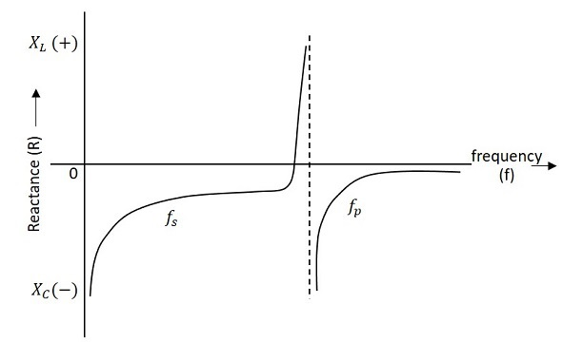

the first one is the series resonant frequency (fs), which occurs when reactance of the inductance (L) is equal to the reactance of the capacitance C. In that case, the impedance of the equivalent circuit is equal to the resistance R and the frequency of oscillation is given by the relation,

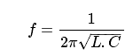

The second one is the parallel resonant frequency (fp), which occurs when the reactance of R-L-C branch is equal to the reactance of capacitor Cm. At this frequency, the crystal offers a very high impedance to the external circuit and the frequency of oscillation is given by the relation.

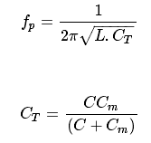

The value of Cm is usually very large as compared to C. Therefore, the value of CT is approximately equal to C and hence the series resonant frequency is approximately equal to the parallel resonant frequency (i.e., fs = fp).

**Crystal Oscillator Circuit**

A crystal oscillator circuit can be constructed in a number of ways like a Crystal controlled tuned collector oscillator, a Colpitts crystal oscillator, a Clap crystal oscillator etc. But the **transistor pierce crystal oscillator** is the most commonly used one. This is the circuit which is normally referred as a crystal oscillator circuit.

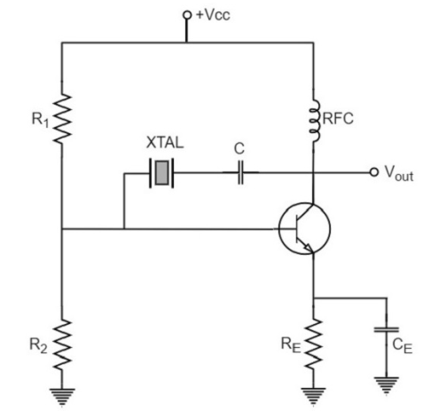

In this circuit, the crystal is connected as a series element in the feedback path from collector to the base. The resistors R1, R2 and RE provide a voltage-divider stabilized d.c. bias circuit. The capacitor CE provides a.c. bypass of the emitter resistor and RFC (radio frequency choke) coil provides for d.c. bias while decoupling any a.c. signal on the power lines from affecting the output signal. The coupling capacitor C has negligible impedance at the circuit operating frequency. But it blocks any d.c. between collector and base.

The circuit frequency of oscillation is set by the series resonant frequency of the crystal and its value is given by the relation,



It may be noted that the changes in supply voltage, transistor device parameters etc. have no effect on the circuit operating frequency, which is held stabilized by the crystal.

### Advantages

* They have a high order of frequency stability.
* The quality factor (Q) of the crystal is very high.

### Disadvantages

* They are fragile and can be used in low power circuits.
* The frequency of oscillations cannot be changed appreciably.

## Frequency Stability of an Oscillator

An Oscillator is expected to maintain its frequency for a longer duration without any variations, so as to have a smoother clear sinewave output for the circuit operation. Hence the term frequency stability really matters a lot, when it comes to oscillators, whether sinusoidal or non-sinusoidal.

The frequency stability of an oscillator is defined as the ability of the oscillator to maintain the required frequency constant over a long time interval as possible. Let us try to discuss the factors that affect this frequency stability.

### Change in operating point

We have already come across the transistor parameters and learnt how important an operating point is. The stability of this operating point for the transistor being used in the circuit for amplification (BJT or FET), is of higher consideration.

The operating of the active device used is adjusted to be in the linear portion of its characteristics. This point is shifted due to temperature variations and hence the stability is affected.

### Variation in temperature

The tank circuit in the oscillator circuit, contains various frequency determining components such as resistors, capacitors and inductors. All of their parameters are temperature dependent. Due to the change in temperature, their values get affected. This brings the change in frequency of the oscillator circuit.

### Due to power supply

The variations in the supplied power will also affect the frequency. The power supply variations lead to the variations in Vcc. This will affect the frequency of the oscillations produced.

In order to avoid this, the regulated power supply system is implemented.

### Change in output load

The variations in output resistance or output load also affects the frequency of the oscillator. When a load is connected, the effective resistance of the tank circuit is changed. As a result, the Q-factor of LC tuned circuit is changed. This results a change in output frequency of oscillator.

### Changes in inter-element capacitances

Inter-element capacitances are the capacitances that develop in PN junction materials such as diodes and transistors. These are developed due to the charge present in them during their operation.

The inter element capacitors undergo change due to various reasons as temperature, voltage etc. This problem can be solved by connecting swamping capacitor across offending inter-element capacitor.

### Value of Q

The value of Q (Quality factor) must be high in oscillators. The value of Q in tuned oscillators determine the selectivity. As this Q is directly proportional to the frequency stability of a tuned circuit, the value of Q should be maintained high.

Frequency stability can be mathematically represented as,

Sw=dθ/dwSw=dθ/dw

Where dθ is the phase shift introduced for a small frequency change in nominal frequency fr. The circuit giving the larger value of (dθ/dw) has more stable oscillatory frequency.